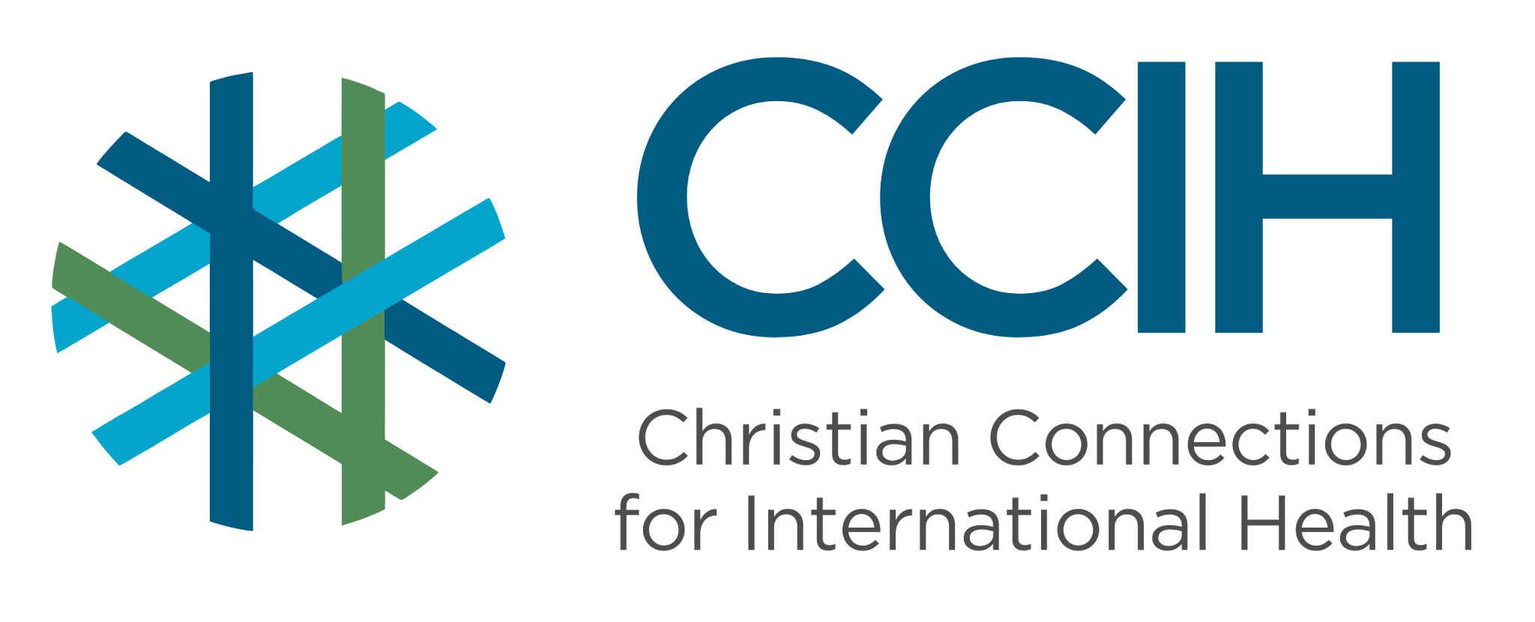
HIV – Talking Points for Faith Actors

What is it?
HIV (Human Immunodeficiency Virus) is a virus that weakens the immune system, making it harder to fight off illness and infection. If HIV is not treated, it can lead to serious illness, AIDS, and death.

Why is it important?
HIV continues to affect the health, well-being, and economic stability of individuals, families, and communities. Although it cannot be cured, it can be effectively treated with medicine so that people living with HIV can prevent transmission to others and live long, healthy lives.

Key Trends and Challenges

Current Trends and Statistics
- About 41 million people are living with HIV worldwide. Sub-Saharan Africa (SSA) carries the heaviest burden; it is home to 65% of all people living with HIV globally.
- In 2024, 630,000 people died from AIDS-related causes globally, and 61% of those deaths occurred in SSA.
- There is real hope. New HIV infections in SSA have dropped by 56% since 2010, showing that progress is possible when communities and health systems work together.

Challenges and Gaps in LMICs
- Many people do not know they are living with HIV.
- Many people who know they are living with HIV are not on treatment.
- Stigma and fear of judgment keep many people from getting tested, continuing their treatment, or telling others about their status.
- Recently, many services to prevent HIV and support people living with HIV have lost their funding.

Populations Most Affected
- Adolescent girls and young women
- People facing stigma in their communities
- Those with limited access to healthcare

Christian Connections for International Health (CCIH) is a global network of Christian organizations and individuals committed to advancing health and wholeness. Learn more at www.ccih.org.

A Faith-Informed Response
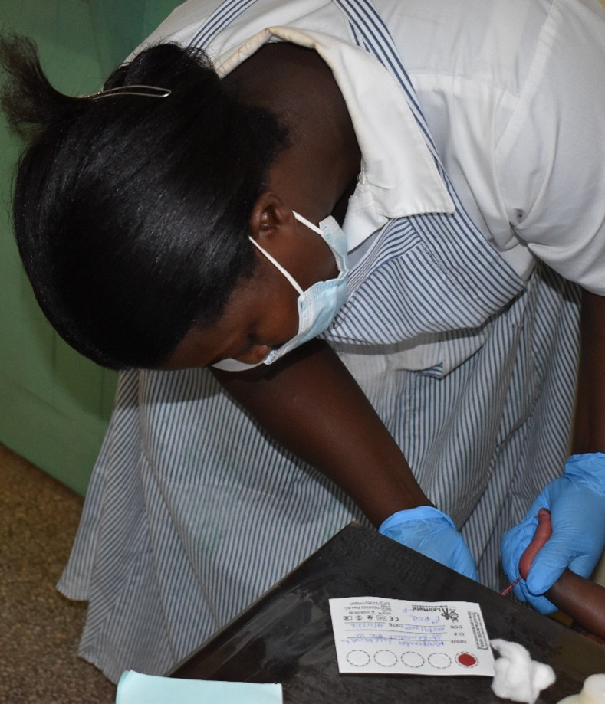
How are faith communities impacted?
- Faith communities include members living with HIV, caring for sick family members, or raising children orphaned by AIDS-related illness. Many people living with HIV sit in silence, afraid of judgment from the very community that should offer them support. Pastors regularly walk alongside families navigating grief, stigma, and financial strain.

Why does this matter to faith communities?
- Every person living with HIV is made in the image of God and deserves to be treated with dignity, compassion, and love. HIV disproportionately affects women, girls, and children, some of the most vulnerable members of our congregations. Faith communities have a responsibility not to look away. How the church responds to HIV and serves people with HIV sends a powerful message about whose lives it values and who belongs in Christian communities.

Why should religious leaders act?
- Religious leaders are uniquely positioned to reduce HIV stigma, promote accurate information, help connect people to care and treatment, and set an example by supporting people living with HIV. Faith leaders hold positions of influence and can advocate for policies that make sure no one is left behind in the HIV response.

Related Scriptures

- “Speak up for the rights of those who cannot speak for themselves, for the rights of all who are destitute.” Proverbs 31:8, NIV
- “I was sick, and you looked after me.” Matthew 25:36, NIV
- “If one of you says to them, 'Go in peace, keep warm and well fed,' but does nothing about their physical needs, what good is it?” James 2:16, NIV
- “Love your neighbor as yourself.” Mark 12:31, NIV
- “There is no fear in love. But perfect love drives out fear.” 1 John 4:18, NIV

Talking Points for Sermons, Meetings, and Social Media

Key Messages to Share
- HIV is not a punishment from God but a treatable health condition.
- With medical care and support, people living with HIV can live full, healthy lives.
- Stigma is a barrier. Our words and actions of support can save lives.
- Knowing your HIV status is an act of love and responsibility.
- Undetectable = Untransmittable (U=U), maintaining an undetectable viral load prevents transmission to others
- People living with HIV deserve the full love, support, and welcome of the church community.

How to Start the Conversation
- Remind your congregation that HIV affects people in every walk of life, including people of deep faith.
- Getting tested and knowing your HIV status is one of the most important things you can do for your health and family.
- Share stories (with permission) of how people of faith living with HIV can thrive and live healthy lives with medical treatment.

Practical Actions for Faith Leaders and Communities

Advocate
- The first step toward breaking the stigma is to preach openly about HIV and end the silence.
- Partner with local health clinics to promote testing and access to treatment, making it easy and safe for congregation members to know their HIV status.
- Advocate with local health authorities for consistent access to HIV testing and treatment in your community. Stopping ARVs for even a brief period can cause HIV loads to skyrocket, placing a new generation of families at risk, so consistent access to treatment is crucial.
- Speak about HIV prevention, including PrEP (Pre-Exposure Prophylaxis), condoms, testing, treatment that prevents transmission, and addressing the social and structural factors that increase vulnerability, such as access to housing, jobs, and healthcare.

Address Stigma and Misconceptions
- Create a culture of compassion in your congregation where people living with HIV feel safe, welcomed, and supported.
- Preach that HIV is a health condition, not a punishment from God.
- Correct any misinformation about HIV in your community.
- Educate vulnerable communities, especially youth, about their rights

Refer People to the Right Services
- Know your nearest HIV testing and treatment center to share with those who need to be connected to health care and support.
- Support families caring for children orphaned by AIDS-related illness by connecting them to social services, counseling, and community care programs.

Resources

- For additional faith-based advocacy tools and biblical resources, visit the Christian Connections for International Health (CCIH) Resource Library, where you can search for “HIV/AIDS” at https://www.ccih.org/resources/
- World Relief. SCOPE HIV Messages of Hope Lesson Series: A Sermon Guide for Church Leaders 2021. worldrelief.org/content/uploads/2022/06/Messages-of-Hope_Christian-Sermon-Guide.pdf
- UNAIDS. Fact Sheet 2025. https://www.unaids.org/en/resources/fact-sheet
- UNAIDS. Global AIDS Update 2025. https://www.unaids.org/en/UNAIDS-global-AIDS-update-2025
- UNICEF. HIV Statistics — Global and Regional Trends. 2024. https://data.unicef.org/topic/hivaids/global-regional-trends/
- World Health Organization. HIV/AIDS Fact Sheet. Geneva: WHO, 2025. https://www.who.int/news-room/fact-sheets/detail/hiv-aids
Why Does this Matter to Me? (Context-Specific) Use this space to write down your thoughts, prayers, data, or talking points.

