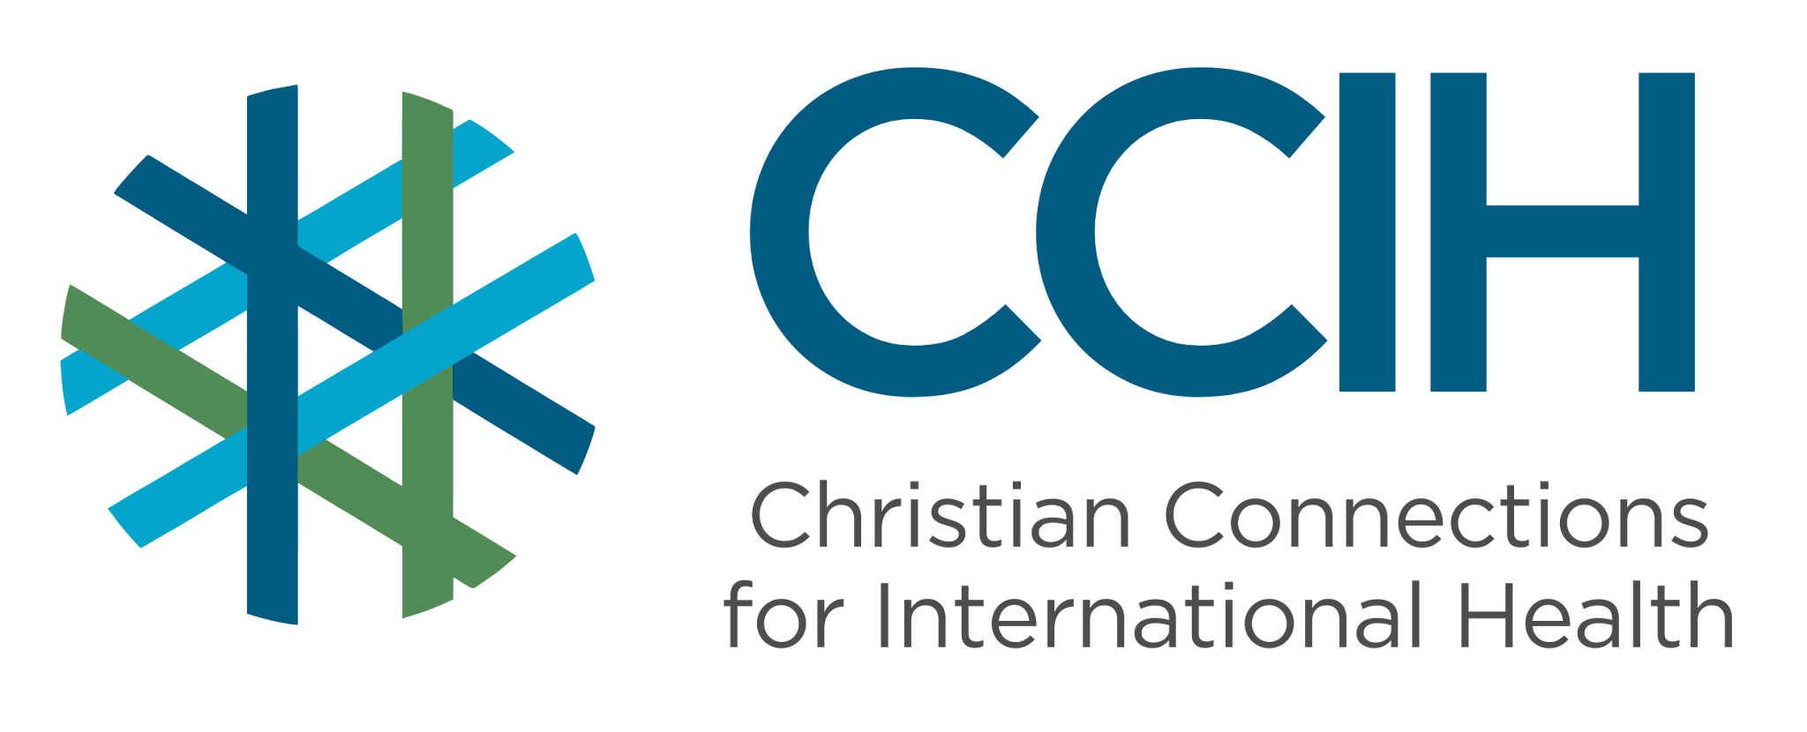
Immunization – Talking Points for Faith Actors

What is it?
Immunization is the process of protecting people from infectious diseases by giving vaccines that help their immune systems develop protection against them.

Why is it important?
Immunization prevents illness, disability, and death from diseases.

What is the difference between immunization and vaccination?
A vaccine is the medicine itself; vaccination is receiving it (most often by injection); and immunization is the result of what happens afterward, when the vaccine causes the body to build protection against diseases.

Key Trends and Challenges

Current Trends and Statistics
- Immunization saves millions of lives every year.
- Global vaccination has stalled in recent years.
- Millions of children miss their vaccinations each year.

Challenges and Gaps in LMICs
- Many people have limited access to health facilities and routine vaccination services.
- It can be hard to get vaccines safely from where they are made to the clinics that need them, especially in remote areas. Vaccines must travel from factories to clinics while staying cold and safe to use. In many places, this journey is difficult due to poor roads, unreliable transportation, or inadequate storage.
- Conflict, instability, and geographic barriers interrupt immunization services.
- Misinformation and hesitancy reduce the number of people seeking immunization.

Populations Most Affected
- Children under 5 who miss their vaccines
- People with limited access to health systems (e.g., live far from health facilities, have less money to pay for transport or health services, live in conflict or displaced situations)

Christian Connections for International Health (CCIH) is a global network of Christian organizations and individuals committed to advancing health and wholeness. Learn more at www.ccih.org.

A Faith-Informed Response
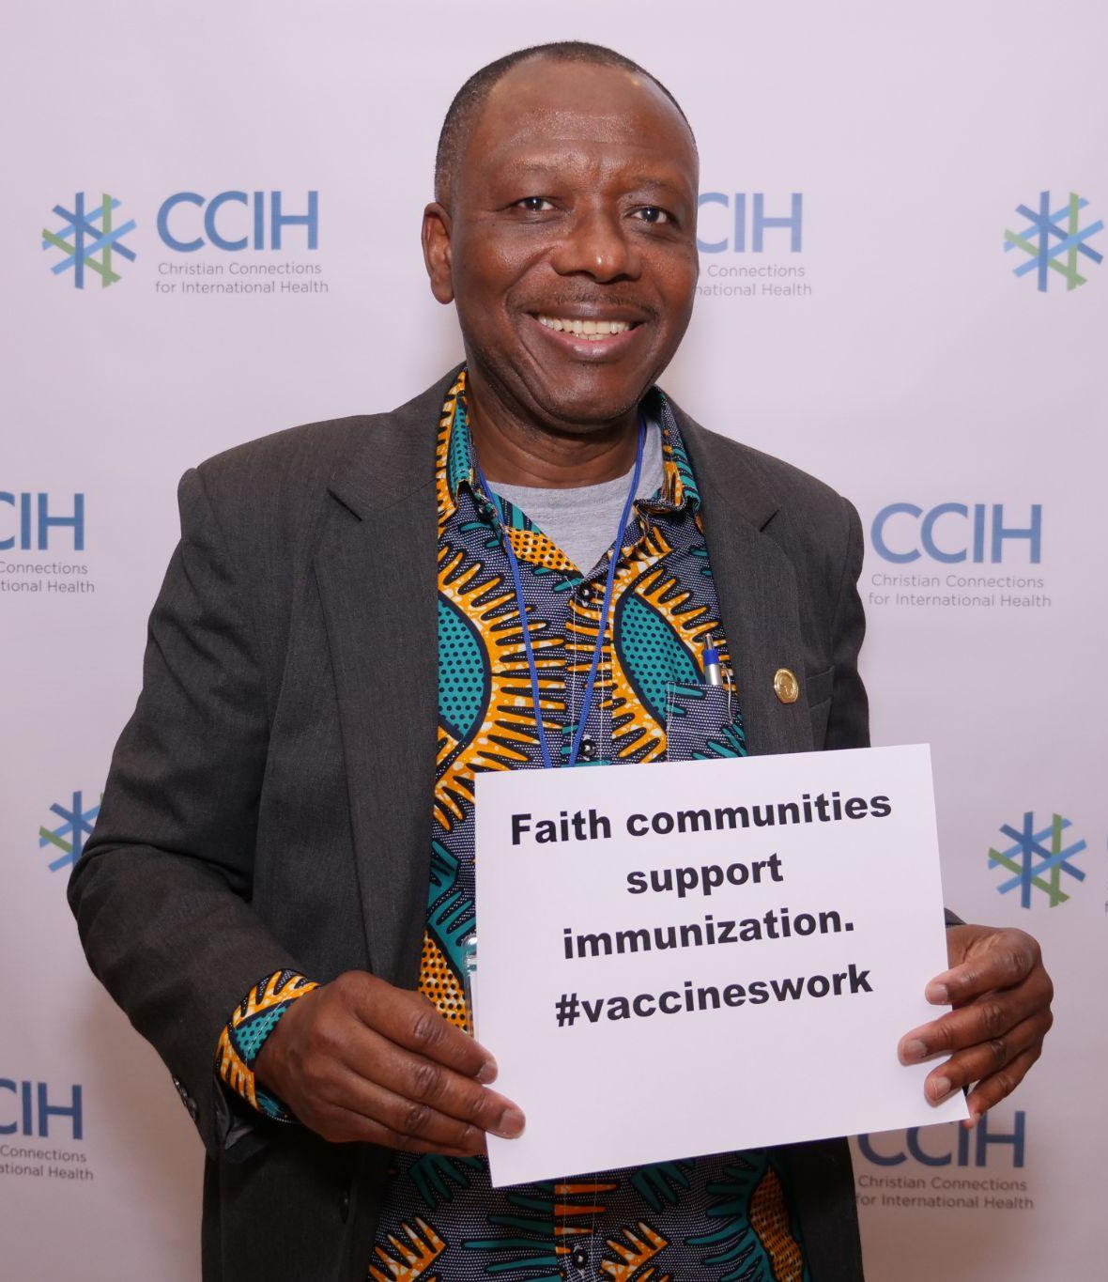
How are faith communities impacted?
- Large church gatherings can unintentionally become places where unvaccinated children are exposed to deadly diseases. When children in a congregation go unvaccinated, the whole community is at risk from contagious diseases (e.g., those that can be passed through the air from person to person). We have seen disease outbreaks of measles, whooping cough, and other diseases sweep through communities within weeks. Consequently, families grieve children lost to diseases that simple vaccines could have stopped.

Why does this matter to faith communities?
- Faith communities are highly vulnerable to vaccine-preventable disease transmission in their congregations due to frequent large gatherings.
- Faith communities can also be powerful partners in preventing the spread of vaccine-preventable diseases.

Why should religious leaders act?
- Religious leaders are trusted voices who can increase vaccine confidence, counter misinformation, and encourage families to seek timely immunization.

Related Scriptures

- “The prudent see danger and seek refuge.” Proverbs 27:12, NIV
- “I was sick, and you looked after me.” Matthew 25:36, NIV
- “If one of you says to them, “Go in peace, keep warm and well fed,” but does nothing about their physical needs, what good is it?” James 2:16, NIV
- “Heal the sick.” Matthew 10:8, NIV

Talking Points for Sermons, Meetings, and Social Media

Key Messages to Share
- The development of modern life-saving medicine is one of the gifts God has so generously given us to reduce suffering and death.
- By vaccinating ourselves and our families, we are showing love for those around us who may be vulnerable to disease and ineligible for vaccination.
- Immunization protects children and families from preventable diseases and saves millions of lives each year.
- Vaccination is a practical way to care for the vulnerable and prevent unnecessary suffering.
- Churches can help build trust, share accurate information, and support families in accessing vaccines.

How to Start the Conversation
- Many childhood diseases today are preventable through immunization.
- Share concern for children who miss routine vaccinations.
- Encourage questions and honest dialogue about vaccines with trusted health providers.
- Explain how immunization helps protect families as well as the broader community.

Practical Actions for Faith Leaders and Communities
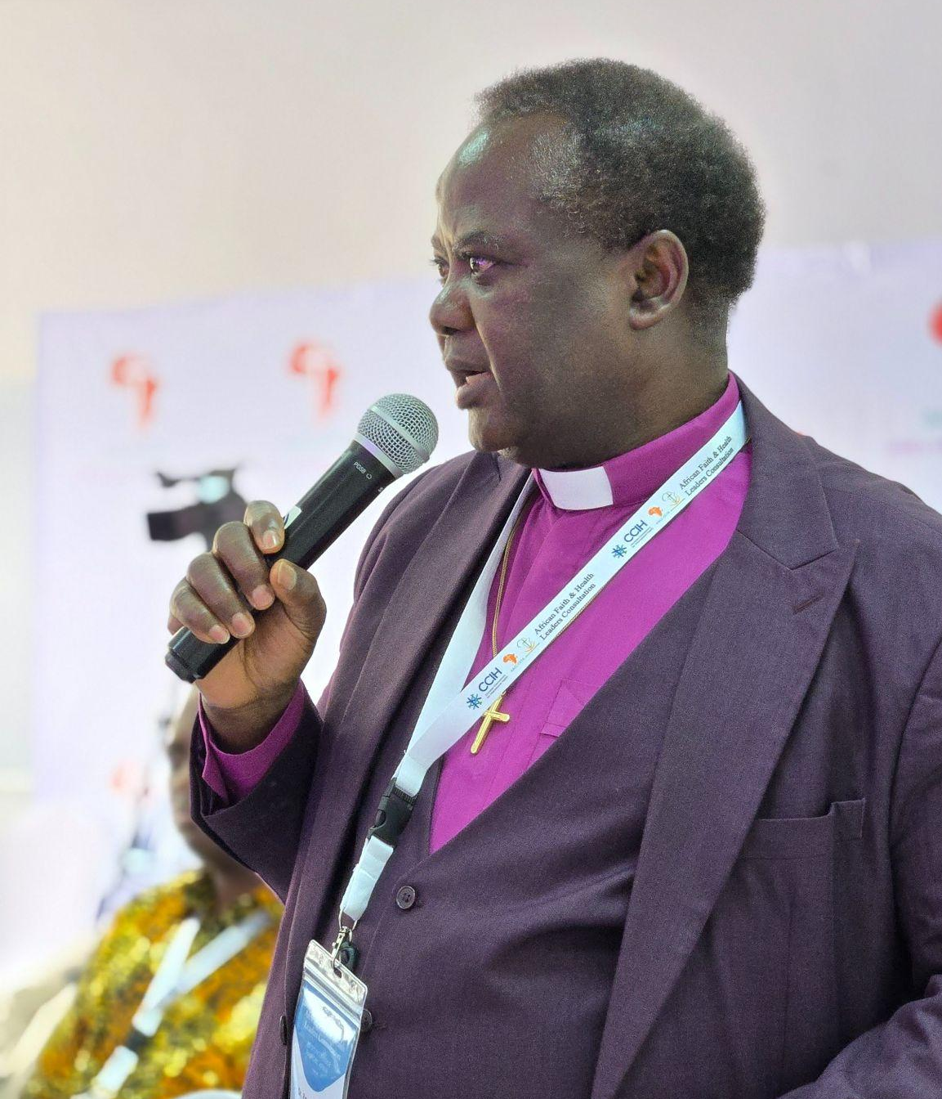
Advocate
- Promote childhood immunization in sermons and at church events.
- Partner with local clinics or health teams to promote vaccination outreach events.
- Use church communication channels to share vaccine information and clinic schedules.
- Advocate to local health authorities for affordable, accessible immunizations.

Address Stigma and Misconceptions
- Correct any misinformation that vaccines are unnecessary or unsafe.
- Emphasize that vaccination is a preventive health measure, not a lack of faith.
- Some vaccinations, like COVID vaccines, may not always prevent you from getting a disease, but they can reduce the severity of the illness and prevent death.
- Encourage respectful dialogue and avoid judgment of hesitant families.

Refer People to the Right Services
- Direct families to nearby clinic locations or immunization days for routine childhood vaccines.
- Connect community members to health care providers for vaccine questions.

Resources

- For additional faith-based advocacy tools and biblical resources, visit the Christian Connections for International Health (CCIH) Resource Library, where you can search for “Immunization” at https://www.ccih.org/resources/
- MOMENTUM. Promoting Vaccination: A Toolkit for Collaborating with Faith Communities. 2022. Washington, DC: USAID MOMENTUM. Resources in English, French, and Hindi. https://www.ccih.org/resource_index/promoting-vaccination-a-toolkit-for-collaborating-with-faith-communities/
- World Health Organization. “Essential Programme on Immunization.” https://www.who.int/teams/immunization-vaccines-and-biologicals/essential-programme-on-immunization
- World Health Organization. “Immunization Coverage.” https://www.who.int/news-room/fact-sheets/detail/immunization-coverage
- World Health Organization. “Immunization, Vaccines, and Biologicals.” https://www.who.int/teams/immunization-vaccines-and-biologicals
Why Does this Matter to Me? (Context-Specific) Use this space to write down your thoughts, prayers, data, or talking points.

