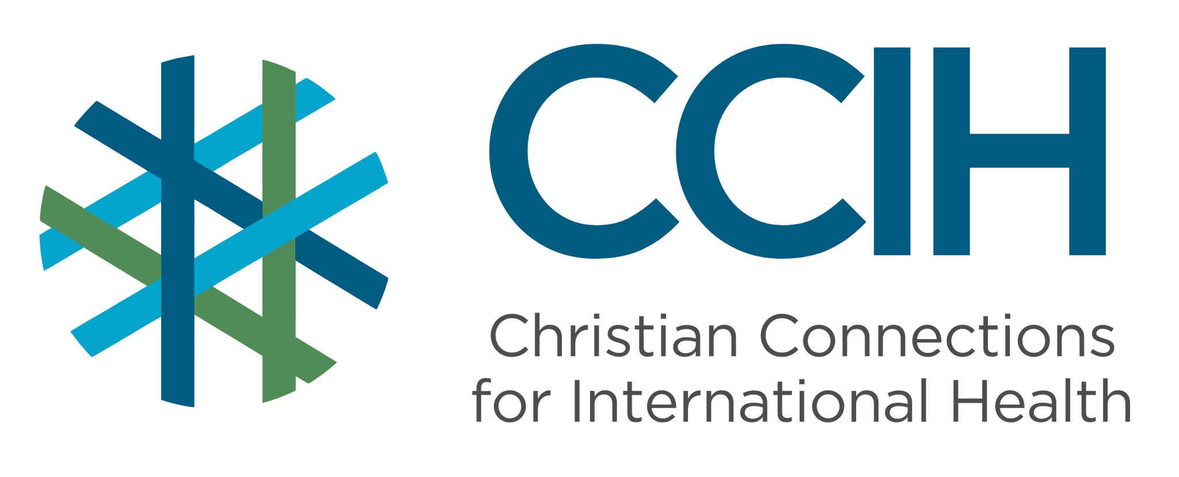
Maternal & Child Health (MCH) – Talking Points for Faith Actors

What is it?
Maternal and Child Health (MCH) refers to the health of women during pregnancy, childbirth, and the postnatal period, as well as that of infants and children.

Why is it important?
Most common maternal and child illnesses and causes of death are preventable. Supporting the health of mothers and children together leads to healthier families, stronger communities, and better lifelong health.

Key Trends and Challenges

Current Trends and Statistics
- Every year, about 260,000 women around the world die from causes related to pregnancy and childbirth. The majority of those deaths happen in low- and middle-income countries.
- Sub-Saharan Africa has the highest death rate for children under five in the world, with about 1 in 14 children dying before their fifth birthday.
- Most of these child deaths are caused by preventable or treatable conditions, including malnutrition, pneumonia, diarrhea, malaria, and complications from preterm birth, meaning that with the right care, most of these young lives could be saved.

Challenges and Gaps in LMICs
- Health facilities often lack sufficient trained staff.
- People in rural or remote areas may have to travel far and find it difficult to access health services.
- The cost of health care can be too high for many families.

Populations Most Affected
- Low-income and marginalized households.
- Adolescent girls and young women experiencing pregnancy.
- Children under 5 years old.
- People living in rural areas with limited access to healthcare.

Christian Connections for International Health (CCIH) is a global network of Christian organizations and individuals committed to advancing health and wholeness. Learn more at www.ccih.org.

A Faith-Informed Response
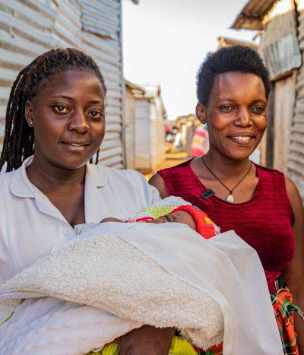
How are faith communities impacted?
- Few losses shake a congregation like the death of a mother or child. When a mother dies in childbirth, her children may be scattered among relatives, her husband left to raise a family alone, and her church family left to mourn what should have been a time of celebration. The death of a young child is also devastating, leaving parents and siblings to grieve a loss that so often is preventable.

Why does this matter to faith communities?
- God calls us to protect life and care for the most vulnerable. Mothers and young children are among the most vulnerable people in our communities. Caring for their health is not just a medical issue; it is a matter of faith and justice.

Why should religious leaders act?
- Scripture calls leaders to speak for those who cannot speak for themselves (Proverbs 31:8). Women and children are often the most voiceless members of society, unable to advocate for the care they deserve. Religious leaders can use their influence to advocate for access to quality healthcare and push back against harmful traditions.

Related Scriptures

- “Speak up for those who cannot speak for themselves, for the rights of all who are destitute.” Proverbs 31:8, NIV
- “I was sick, and you looked after me." Matthew 25:36, NIV
- “If one of you says to them, 'Go in peace, keep warm and well fed,' but does nothing about their physical needs, what good is it?” James 2:16, NIV
- “Love your neighbor as yourself.” Mark 12:31, NIV

Talking Points for Sermons, Meetings, and Social Media

Key Messages to Share
- Most maternal and child deaths are preventable with timely care.
- Seeking medical and mental health care during pregnancy and for young children is wise, responsible, and fully consistent with trusting God.
- God calls us to protect life, and that begins before a child is even born. Supporting pregnant women in our communities is an act of faith.
- Every child is a gift from God. Making sure children receive vaccinations, proper nutrition, and medical care when sick is how we honor that gift.

How to Start the Conversation
- “No mother should die giving life. No child should die before they have a chance to live.”
- Encourage women to begin prenatal care early and keep their appointments.
- Encourage families to bring infants and children to regular check-ups.
- Share stories of families helped by skilled birth attendants or community health workers.

Practical Actions for Faith Leaders and Communities
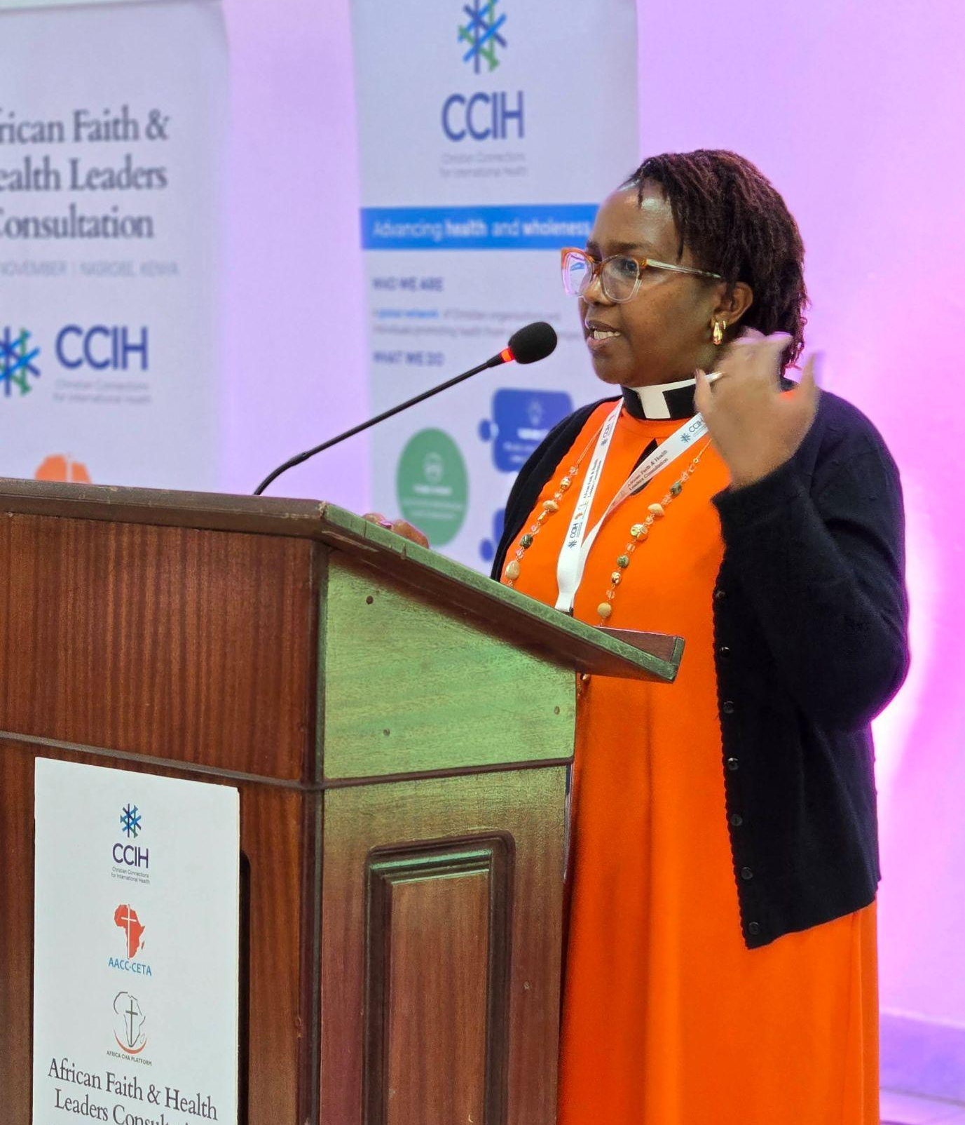
Advocate
- Use church activities and sermons to teach about the value of prenatal care, skilled birth attendance, and children’s health care.
- Partner with local health programs to promote quality maternal and child health services.
- Advocate with local health authorities for affordable and accessible maternal and child health care.

Address Stigma and Misconceptions
- Gently challenge the belief that maternal and child deaths are just “God’s will” or something that needs to be accepted and cannot change.
- Address stigma about maternal mental health and communicate that mothers do not need to suffer in silence.
- Correct misinformation about maternal and child health in small group settings and from the pulpit.
- Model respectful, supportive attitudes toward pregnant women in your congregation.

Refer People to the Right Services
- Direct pregnant women to antenatal clinics as early as possible, ideally in the first three months of pregnancy.
- Encourage families to plan for delivery at a health facility with a trained attendant present.
- Connect families with community health workers and ensure they know how to access emergency referral services.
- Encourage parents to bring children under five for regular health visits to monitor growth, complete their vaccinations, and catch any illnesses early before they become serious.

Resources

- For additional faith-based advocacy tools and biblical resources, visit the CCIH Resource Library, where you can search for “maternal and child health” at https://www.ccih.org/resources/
- Pfeiffer, Erin; Bormet, Mona; Church, Deirdre; Stalls, Suzanne; Fitzgerald, Laura; McNab, Shanon; Kinsella, Caroline; and Doggett, Elizabeth. 2023. Maternal Mental Health: A Toolkit for Engaging Faith Actors as Change Agents. Washington, DC: USAID MOMENTUM. https://www.ccih.org/wp-content/uploads/2025/02/Maternal-Mental-Health-Toolkit-for-Engaging-Faith-Actors.pdf
- UNFPA. Trends in Maternal Mortality: 2000 to 2023. Geneva: WHO, April 2025. https://www.unfpa.org/publications/trends-maternal-mortality-2000-2023
- UNICEF. Child Mortality (Under 5 Years) Data. 2024. https://data.unicef.org/topic/child-survival/under-five-mortality/
- World Health Organization. Child Mortality (Under 5 Years) Fact Sheet. Geneva: WHO, 2026. https://www.who.int/news-room/fact-sheets/detail/child-mortality-under-5-years
- World Health Organization. Maternal Health. https://www.who.int/health-topics/maternal-health
Why Does this Matter to Me? (Context-Specific) Use this space to write down your thoughts, prayers, data, or talking points.

