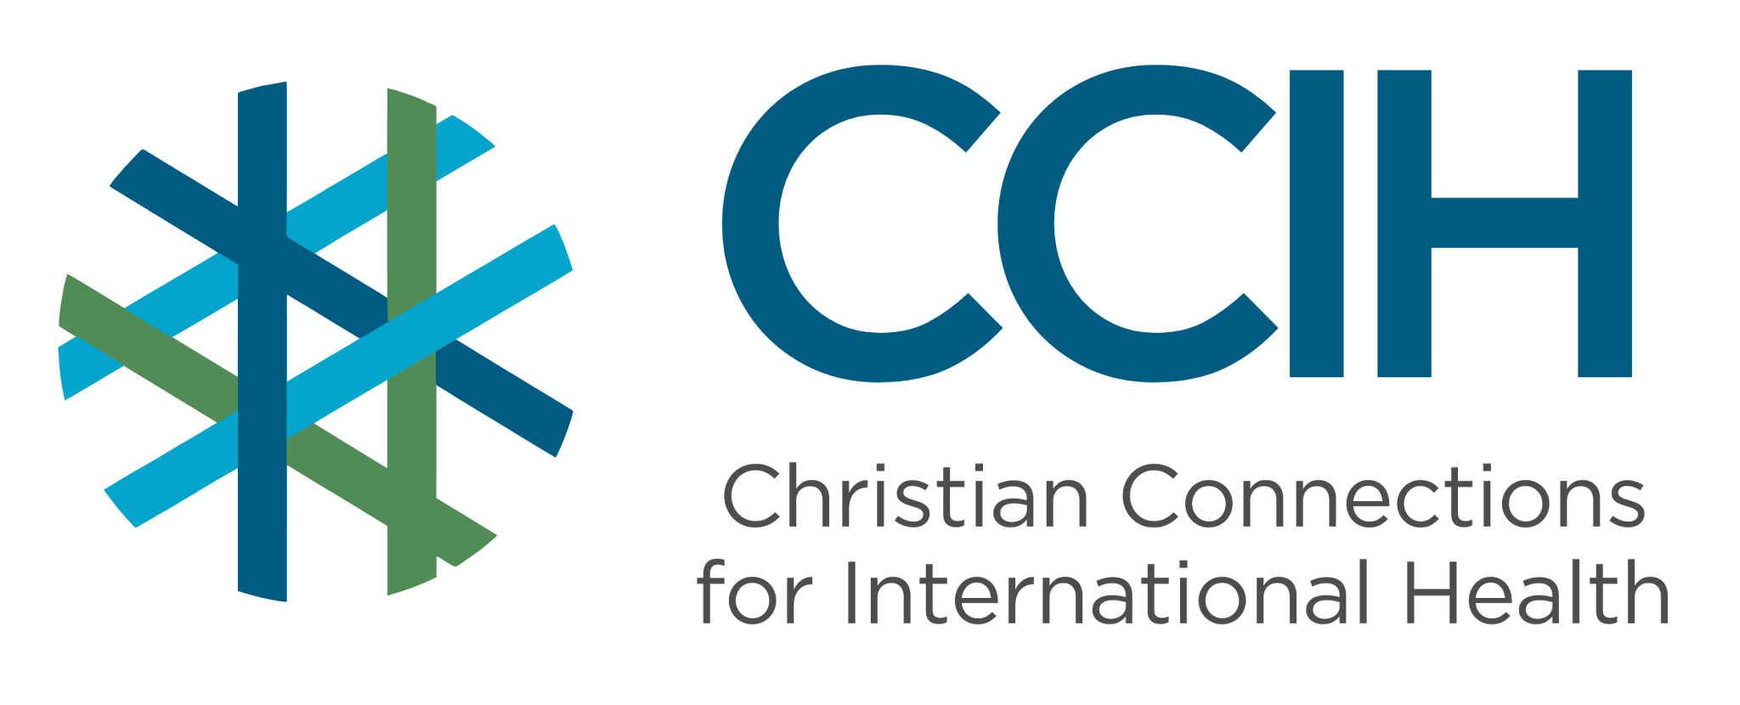
Malaria – Talking Points for Faith Actors

What is it?
Malaria is a disease caused by a parasite passed to humans by mosquito bites. It can cause symptoms like fever, chills, and headaches.

Why is it important?
Malaria is one of the most common diseases in countries that have a more tropical, rainy, and warm climate and can cause severe illness and death.

Key Trends and Challenges

Current Trends and Statistics
- Over 260 million malaria cases occur every year.
- Most malaria deaths (95%) occur in Sub-Saharan Africa (SSA).
- Malaria is the leading killer of children under 5 in SSA.

Challenges and Gaps in LMICs
- Limited access to health care and malaria treatment.
- Inadequate funding and health infrastructure.
- Rising temperatures, changing rainfall patterns, and flooding are expanding mosquito habitats and making malaria transmission less predictable.

Populations Most Affected
- Children under 5 years old.
- Pregnant women.
- Rural and low-income communities.

Christian Connections for International Health (CCIH) is a global network of Christian organizations and individuals committed to advancing health and wholeness. Learn more at www.ccih.org.

A Faith-Informed Response
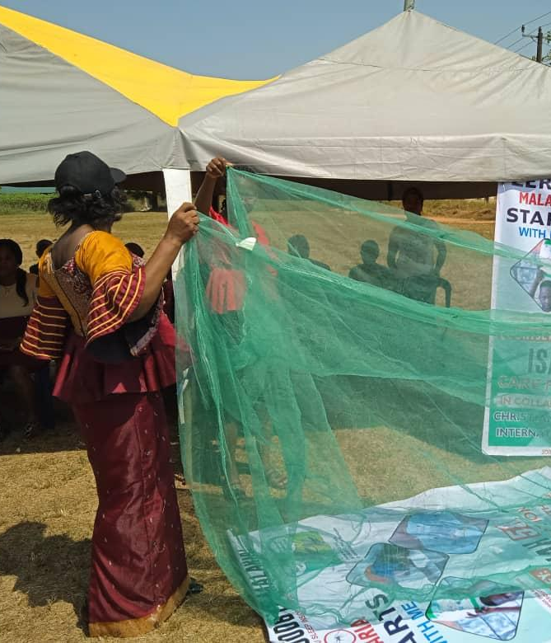
How are faith communities impacted?
- Malaria hits faith communities where it hurts the most: in their families, their finances, and their futures. When a child becomes sick, parents miss work, and savings disappear on treatment costs. When a breadwinner is taken by malaria, a family can fall into poverty overnight. When a child dies from a disease that a bed net or early treatment could have prevented, the grief that fills the church is a grief that did not have to happen.

Why does this matter to faith communities?
- Malaria is one of the most preventable diseases in the world, yet it continues to take the lives of children and adults every single day. For faith communities, this is not just a health issue; it is a justice issue. Christ calls us to protect the vulnerable, and children under five and pregnant women are the most vulnerable of all. The church is uniquely positioned to change this because we already have the trust, relationships, and reach to make sure families have the knowledge and tools they need to stay safe.

Why should religious leaders act?
- Women and children are the least able to protect themselves from malaria or demand better access to prevention and care. Religious leaders can be their advocates. Pastors and faith leaders are among the most trusted voices in any community, and that trust is a powerful tool. When a religious leader speaks up about using bed nets and seeking treatment early, people listen and act. Lives can be saved simply because a trusted leader said the right thing at the right time.

Related Scriptures

- “I was sick, and you looked after me.” Matthew 25:36, NIV
- “If one of you says to them, 'Go in peace, keep warm and well fed,' but does nothing about their physical needs, what good is it?” James 2:16, NIV
- “Heal the sick.” Matthew 10:8, NIV

Talking Points for Sermons, Meetings, and Social Media

Key Messages to Share
- Caring for your family’s health is an act of faith. Using a bed net, seeking treatment early, and protecting your children from malaria is good stewardship of the lives God has given us.
- Malaria is preventable, and children under five and pregnant women are most at risk; protecting them is protecting our future.
- Malaria can be fully cured with just a few tablets. It's important to finish the full course of treatment, even when you feel better.
- If someone has a fever, chills, or feels very tired, seek medical care right away. Malaria can kill quickly, so early treatment saves lives.

How to Start the Conversation
- “This week, I want to challenge every family in this church to check: do you have a bed net, and is your child sleeping under it every night?”
- Share that malaria is both preventable and treatable; the key is acting fast at the first sign of symptoms rather than waiting to see if it gets worse.
- Share where people can get insecticide-treated bed nets and indoor residual spray (IRS).
- Share stories (with permission) of how people of faith have successfully prevented malaria and how those who sought early medical treatment fully recovered.

Practical Actions for Faith Leaders and Communities
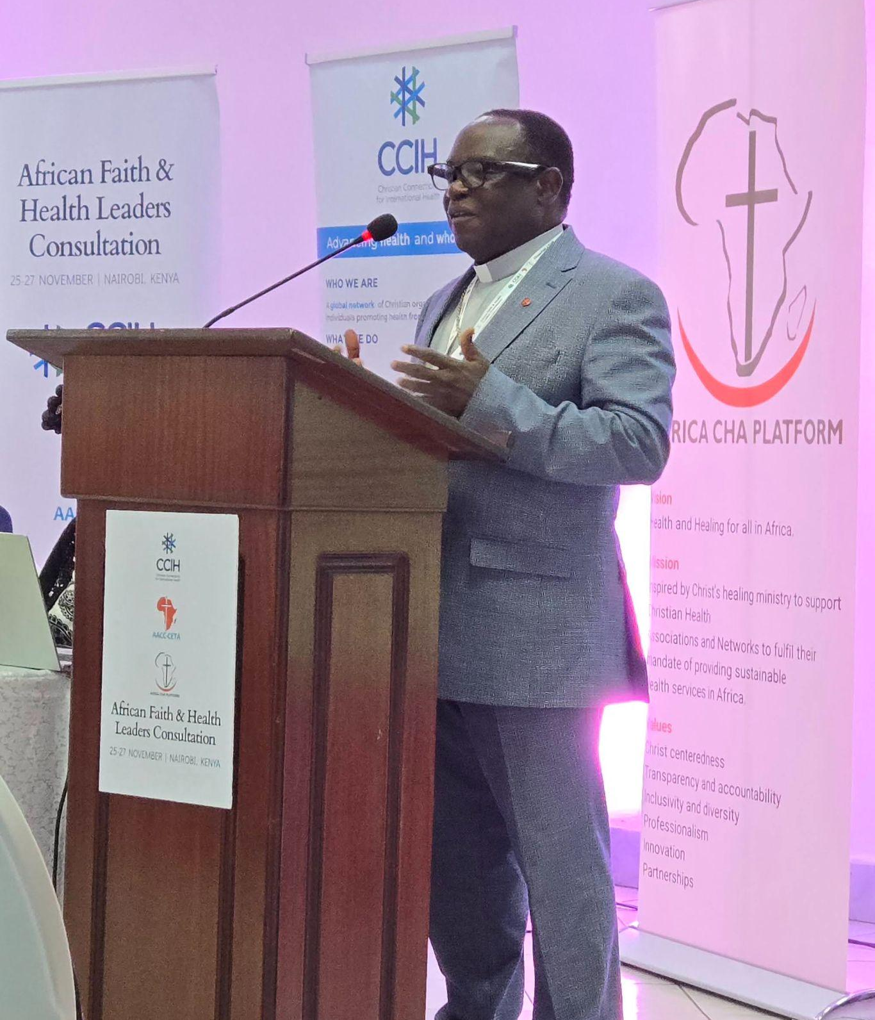
Advocate
- Use church announcements and sermons to teach about the importance of bed nets, early malaria treatment, and vaccinations.
- Partner with local health programs to promote insecticide-treated bed nets, vaccinations, and testing.
- Advocate with local health authorities to support malaria prevention and treatment services, including expanding vaccine availability.

Address Stigma and Misconceptions
- Teach clearly that malaria is preventable and not a punishment or spiritual curse.
- Teach that the malaria vaccine is safe and saves children’s lives.
- Correct misinformation during sermons or small group discussions.
- Encourage compassion rather than blame toward affected families.

Refer People to the Right Services
- Point families to local programs that provide insecticide-treated bed nets, indoor residual spraying, and, where available, vaccinations.
- Direct sick individuals to community health workers, clinic locations, or hospitals for testing and treatment.
- Encourage early care-seeking instead of home remedies.

Resources

- For additional faith-based advocacy tools and biblical resources, visit the Christian Connections for International Health (CCIH) Resource Library, where you can search for “malaria” at https://www.ccih.org/resources/
- Faith Leader Advocacy for Malaria Elimination. https://www.flamemalaria.org/
- IMA World Health. Christian Malaria Sermon Guide. 2019. https://imaworldhealth.org/technical-resources/christian-malaria-sermon-guide
- World Health Organization. Malaria. https://www.who.int/health-topics/malaria
- World Health Organization. World Malaria Report 2024. Geneva: WHO, 2024. https://www.who.int/teams/global-malaria-programme/reports/world-malaria-report-2024
Why Does this Matter to Me? (Context-Specific) Use this space to write down your thoughts, prayers, data, or talking points.

