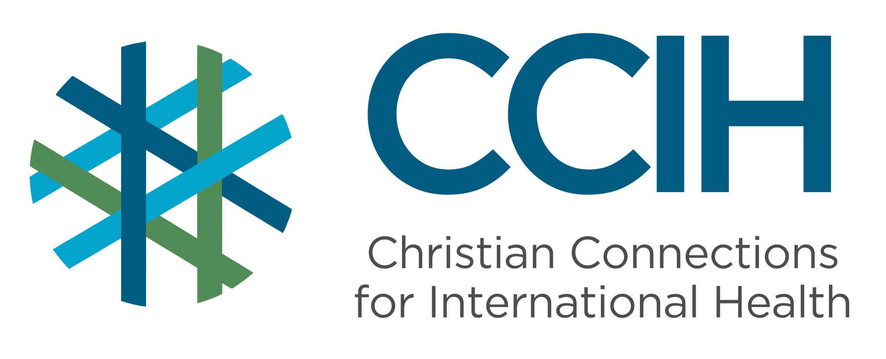
Non-Communicable Diseases (NCDs) – Talking Points for Faith Actors

What is it?
Non-communicable diseases (NCDs) are long-term health conditions that are not passed from person to person. The most common NCDs are heart disease, stroke, diabetes, cancer, and chronic lung disease.

Why is it important?
NCDs are one of the fastest-growing causes of death and disability in Sub-Saharan Africa (SSA). They often go undiagnosed for years, silently damaging people’s health. Early detection and consistent care can prevent serious harm and save lives.

Key Trends and Challenges

Current Trends and Statistics
- NCDs cause about 37% of all deaths in SSA, and the number continues to grow.
- High blood pressure affects 1 in 3 adults in SSA, yet most people do not know they have it.
- Diabetes cases in Africa are expected to double by 2045.
- Heart disease is the most common cause of NCD deaths in Africa.
- Between 60% and 70% of women in African countries are diagnosed with cancer at a late stage.
- By the year 2030, more people in Sub-Saharan Africa (SSA) are expected to die from non-communicable diseases than from communicable diseases.

Challenges and Gaps in LMICs
- Most health systems are set up to treat infectious diseases, not NCDs.
- Medicine for NCDs, such as insulin for diabetes and blood pressure pills, is often unaffordable and inaccessible.
- There are very few trained NCD health care specialists in SSA, and rural communities have limited access to NCD care.
- The majority of women in African countries are diagnosed with cancer at a late stage, when treatment is difficult.

Populations Most Affected
- Adults over 40 years old, although more young people are being affected.
- People with unhealthy diets, a lack of physical activity, and high stress.
- Low-income households that cannot afford medicines or consistent follow-up medical care.
- Women who do not have access to breast and cervical cancer screening.

Christian Connections for International Health (CCIH) is a global network of Christian organizations and individuals committed to advancing health and wholeness. Learn more at www.ccih.org.

A Faith-Informed Response
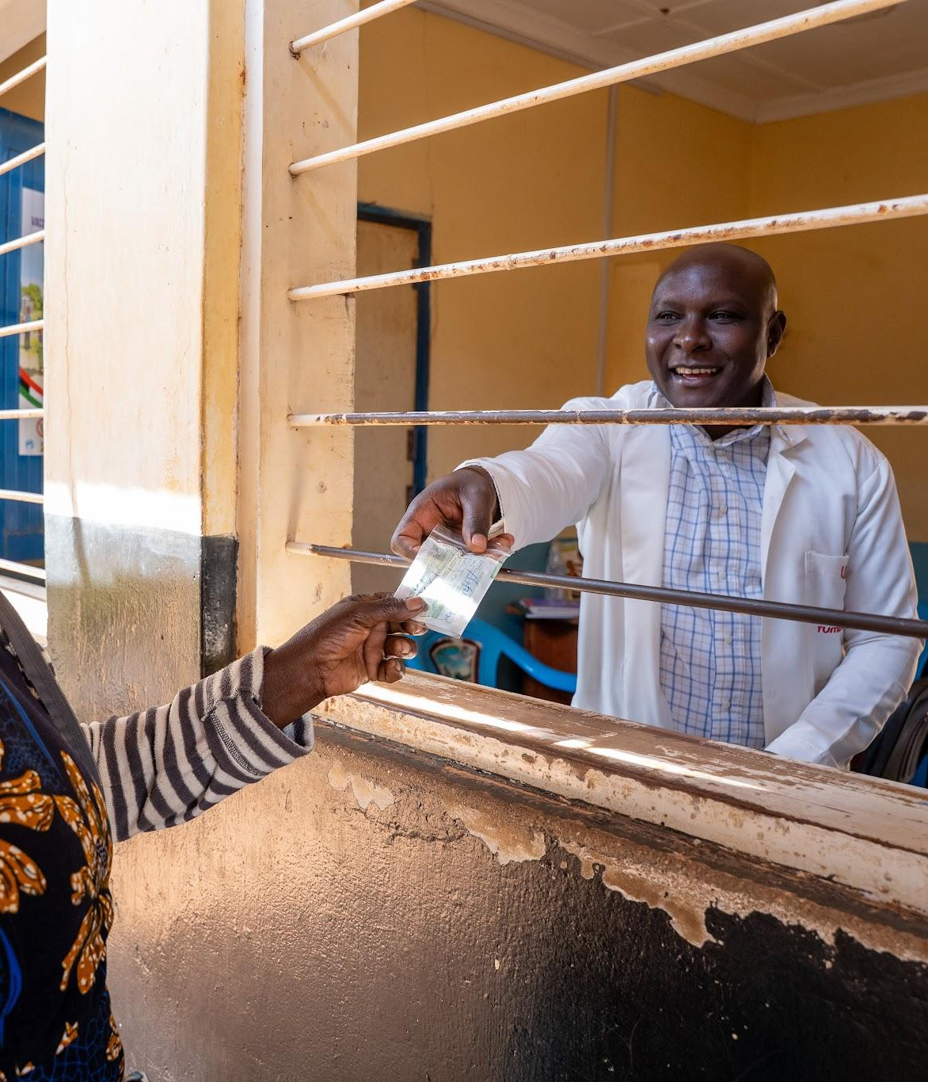
How are faith communities impacted?
- NCDs slowly rob congregations of some of their most valued members, including elders, deacons, and parents. A heart attack, a stroke, or uncontrolled diabetes can take a breadwinner in an instant or leave a family caring for someone who is chronically ill for years. Unlike infections, NCDs often have no visible symptoms until serious damage is done, meaning families are frequently caught off guard.

Why does this matter to faith communities?
- Our bodies are a gift from God. Caring for our health and helping others care for theirs is an act of stewardship and love. Faith communities are well placed to promote healthy living, reduce shame around illness, and help people access the care they need.

Why should religious leaders act?
- Many people visit a place of worship long before they visit a clinic. Leaders who speak openly about NCDs can break down the silence and stigma that allow these diseases to go untreated. Faith leaders can be the first to notice when someone is struggling, the first to encourage them to seek care, and a steady source of support throughout treatment.

Related Scriptures

- “Do you not know that your bodies are temples of the Holy Spirit?” 1 Corinthians 6:19, NIV
- “Dear friend, I pray that you may enjoy good health and that all may go well with you.” 3 John 1:2, NIV
- “I was sick, and you looked after me.” Matthew 25:36, NIV

Talking Points for Sermons, Meetings, and Social Media

Key Messages to Share
- NCDs like high blood pressure, diabetes, and cancer can often be managed, but seeking care early is key to success.
- Taking care of your body is good stewardship.
- Our church can be a place where people learn about their health and find the support they need.

How to Start the Conversation
- “Do you know your blood pressure? When did you last have a health check-up?”
- Share that many people in our communities are living with silent conditions they are unaware of.
- Talk openly about people (with permission) who have lived well with an NCD through faith and medical care.

Practical Actions for Faith Leaders and Communities
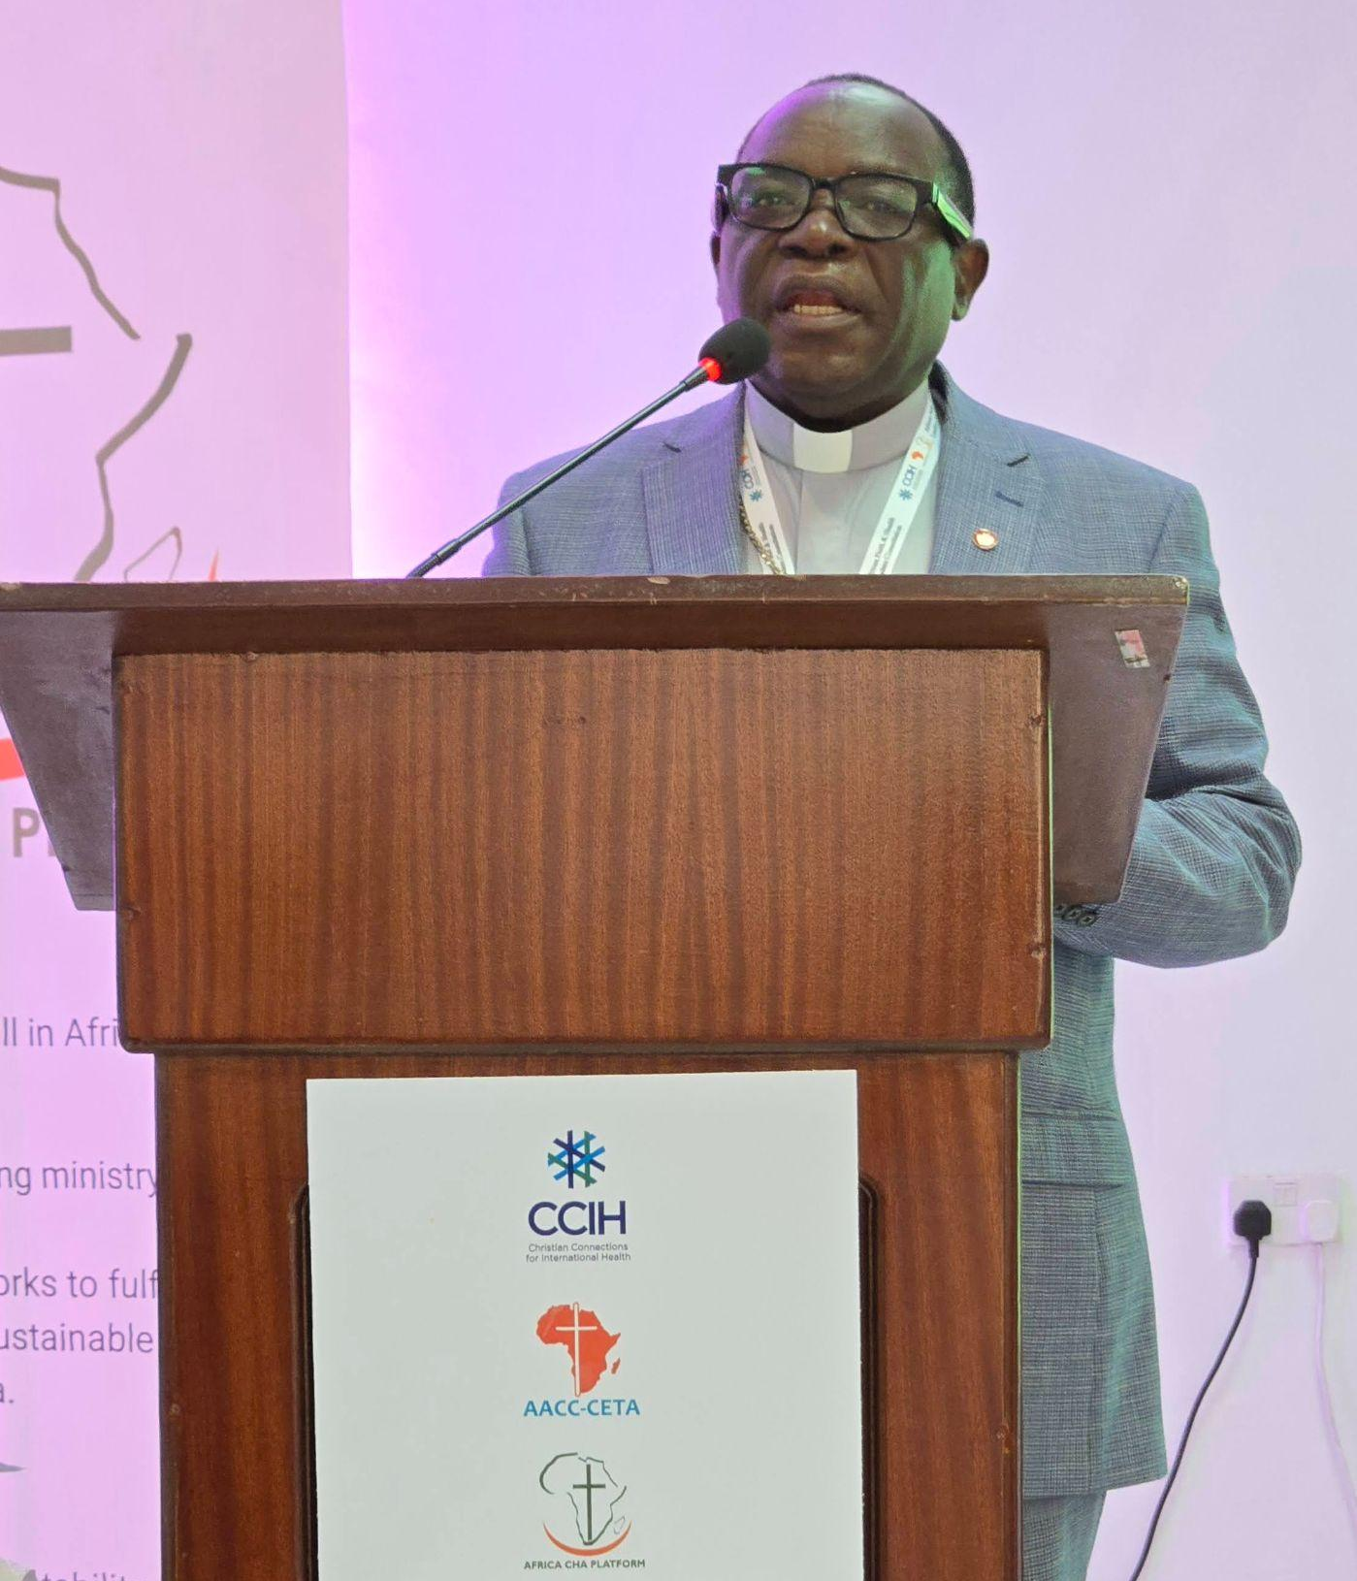
Advocate
- Use church announcements and sermons to encourage members to get regular health screenings, especially for blood pressure, blood sugar, and cancer.
- Invite a local health worker to speak at a church health day, offer basic screenings, and connect people to community health care.
- Advocate with local health authorities for affordable NCD medicines and consistent supply at clinics.

Address Stigma and Misconceptions
- NCDs are NOT a punishment from God or a result of personal failure.
- Prayer is a tool, and so is medical care. They can both be used.
- Create a safe space in your congregation where people can talk honestly about chronic illness without shame.

Refer People to the Right Services
- Connect members to community resources where they can receive regular health check-ups and quickly direct those with symptoms to a clinic.
- Connect people managing chronic conditions to community health workers who can support continued medical care and follow-up visits.

Resources

- For additional faith-based advocacy tools and biblical resources, visit the Christian Connections for International Health (CCIH) Resource Library, where you can search for “non-communicable diseases” at https://www.ccih.org/resources/
- WHO Regional Office for Africa. https://www.afro.who.int/health-topics/noncommunicable-diseases
- Bigna & Noubiap, The Lancet Global Health, October 2019. https://doi.org/10.1016/S2214-109X(19)30370-5
- WHO Global Health Observatory. Cause-specific mortality 2000–2019. Geneva: WHO, 2023. https://www.who.int/data/gho/data/themes/mortality-and-global-health-estimates
- WHO AFRO Investment Case. Addressing the Burden of NCDs in the African Region through the PEN-Plus Regional Strategy. https://www.afro.who.int/publications
Why Does this Matter to Me? (Context-Specific) Use this space to write down your thoughts, prayers, data, or talking points.

