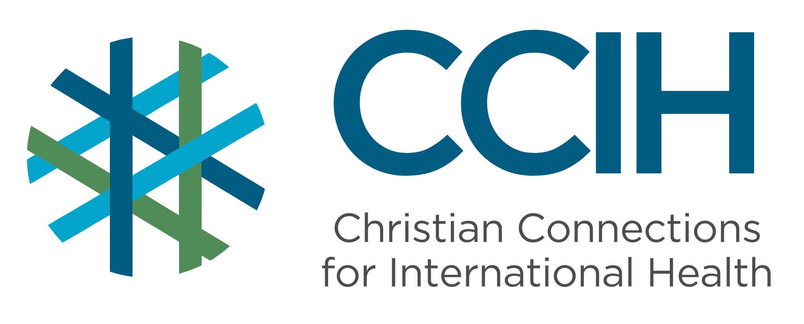
Tuberculosis (TB) – Talking Points for Faith Actors

What is it?
Tuberculosis (TB) is a contagious bacterial infection spread through the air. It primarily affects the lungs but can also spread to other parts of the body.

Why is it important?
TB is a leading global infectious disease and can cause serious illness and death if not treated.

Key Trends and Challenges

Current Trends and Statistics
- TB remains the infectious disease causing the most deaths globally.
- An estimated 10.7 million people were newly diagnosed with TB in 2024.
- Common medicines no longer work on some types of TB.

Challenges and Gaps in LMICs
- Many people have limited access to early TB testing and quality treatment.
- TB-related stigma leads to delayed testing and treatment.
- The long duration of treatment causes many people to give up before finishing.

Populations Most Affected
- People living in crowded conditions.
- People with weakened immune systems.
- Those in close contact with people with active TB disease.

Christian Connections for International Health (CCIH) is a global network of Christian organizations and individuals committed to advancing health and wholeness. Learn more at www.ccih.org.

A Faith-Informed Response
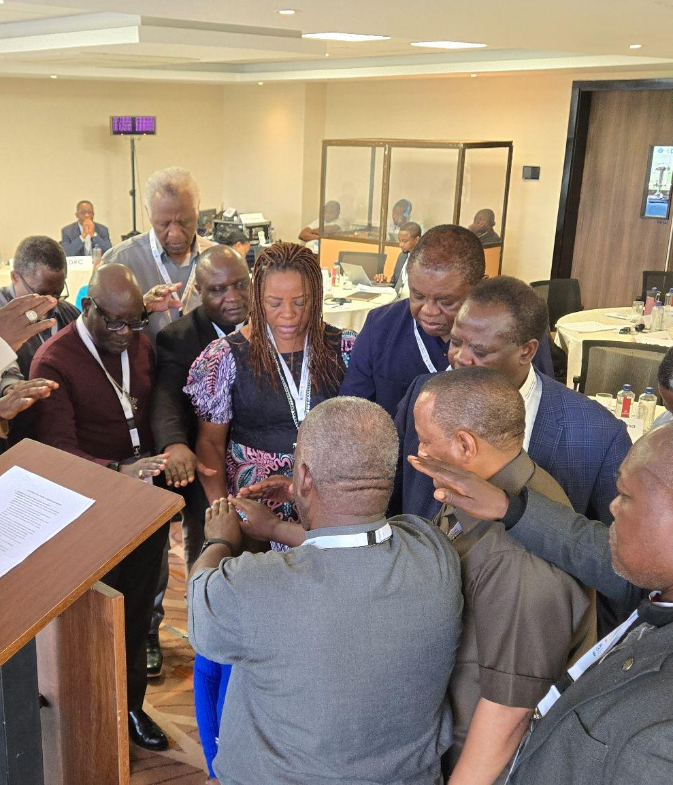
How are faith communities impacted?
- Tuberculosis spreads quietly through households and communities, often reaching multiple family members before it is caught. Faith communities feel this when families lose their primary earners for months during treatment, caregivers become exhausted, and the stigma of TB causes some members to withdraw from church life out of fear or shame. Pastors and leaders often witness families falling into poverty because of a disease that can be cured.

Why does this matter to faith communities?
- TB is a disease that strikes people in the prime of their lives, including parents, providers, church leaders, and young people with their entire future ahead of them. Christ calls us to care for the sick and the suffering, and TB gives faith communities a clear opportunity to live that out. When someone in our congregation suffers alone because they fear being judged, we have failed in our calling. The church should be the first place people feel safe enough to find support.

Why should religious leaders act?
- People living with TB are often too sick, too ashamed, or too afraid to speak up for themselves and may quietly disappear from church life. Religious leaders can change that by speaking openly about TB from the pulpit, visiting and supporting those going through treatment, and making it clear to everyone in the community that no one suffers alone.

Related Scriptures

- “Speak up for those who cannot speak for themselves, for the rights of all who are destitute.” Proverbs 31:8, NIV
- “I was sick, and you looked after me.” Matthew 25:36, NIV
- “If one of you says to them, 'Go in peace, keep warm and well fed,' but does nothing about their physical needs, what good is it?” James 2:16, NIV

Talking Points for Sermons, Meetings, and Social Media

Key Messages to Share
- TB is preventable, treatable, and curable with early care.
- Early testing for TB saves lives and reduces transmission.
- Faith communities can reduce stigma by welcoming and supporting people living with TB.

How to Start the Conversation
- “A persistent cough should never be ignored; early testing saves lives.”
- Encourage compassion and support for people who must take TB medicine for many months. It can be hard to stick with, and they need support to finish treatment.
- Frame care-seeking as loving one’s neighbor.
- Share stories (with permission) of how people of faith sought early TB testing, finished their treatment, and successfully recovered.

Practical Actions for Faith Leaders and Communities

Advocate
- In your sermons and church programs, teach your congregation about TB symptoms and prevention; remind them that TB is an illness, not something to be ashamed of; and assure them that the church supports members who are affected by TB.
- Partner with local health systems for TB screening and awareness campaigns.
- Advocate with local health authorities to support and expand TB services.

Address Stigma and Misconceptions
- Clearly state that TB is a medical condition, not a spiritual punishment.
- Correct misinformation in teaching and group discussions.
- Encourage compassion and inclusion for those affected by TB.

Refer People to the Right Services
- Encourage anyone with a persistent cough to seek testing immediately.
- Share information about specific places in your community for testing and treatment.
- Support completion of treatment by encouraging follow-up care.
- Encourage early care-seeking instead of home remedies.

Resources

- For additional faith-based advocacy tools and biblical resources, visit the Christian Connections for International Health (CCIH) Resource Library, where you can search for “Tuberculosis” at https://www.ccih.org/resources/.
- Berkley Center for Religion, Peace, and World Affairs at Georgetown University. Experiences and Issues at the Intersection of Faith & Tuberculosis. 2010. https://s3.amazonaws.com/berkley-center/100716ExperiencesIssuesIntersectionFaithTuberculosis.pdf
- World Health Organization. Tuberculosis Fact Sheet. Geneva: WHO, 2026. https://www.who.int/news-room/fact-sheets/detail/tuberculosis
- World Health Organization. “Tuberculosis.” https://www.who.int/news-room/fact-sheets/detail/tuberculosis
- World Health Organization. “Global Tuberculosis Programme.” 2026. https://www.who.int/teams/global-tuberculosis-programme
Why Does this Matter to Me? (Context-Specific) Use this space to write down your thoughts, prayers, data, or talking points.

